

**Provisioning Template for V11 to V12 Configuration Migration**

**User Guide**

|  |  |  |
| --- | --- | --- |
| **Version** | **Remarks** | **Date** |
| **1.0** | **Provisioning Template User Guide for V11 to V12 configuration Migration** | **27/01/2017** |
| **2.0** | **Updated document with installation of the template.** | **14/02/2017** |
|  |  |  |
|  |  |  |

## Installation of the Template and Helper Script

1. Login to AppViewX.
2. On the left navigation menu, select ***Provisioning***; and click ***Template.***
3. On the upper right portion of the screen click on the  Import button.
4. The following screen will appear. 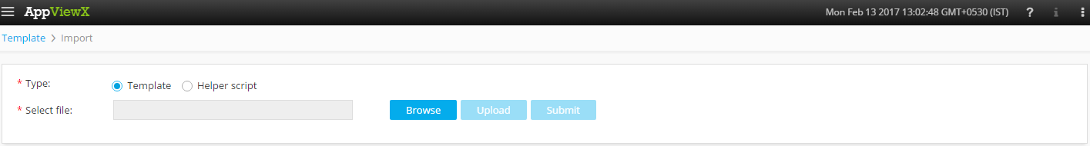
5. Please Select Template/Helper Script.  
   If Template is chosen,
   1. Click on *Browse* and select the Zip File of the template which has to be installed/imported and click open.
   2. Click on upload to import the Zip file and display the templates present in the zip file.
   3. Click on submit to deploy the templates into the AppViewX Environment.

If Helper Script is chosen,

1. Click on *Browse* and select the Zip File of the Helper script which has to be installed/imported and click open.
2. Click on upload to import the Zip file and display the Helper Scripts present in the zip file.
3. Click on submit to deploy the Helper Scripts into the AppViewX Environment.

## V11 to V12 Configuration Migration.

1. Login to AppViewX.
2. On the left navigation menu, select ***Provisioning***; and click ***Request.***
3. On the upper right portion of the screen, click the  ***Create*** button.
4. Select the provisioning template name from the list –‘**F5-Multiple-V11_to_V12-Config-Migration**’

**Note:** *If no template is available, this indicates that the user role does not have permission to the requesting template.*

1. Enter the provisioning request description – ‘Configuration Migration’.
2. Enter the **Request Scenario Name** relevant to the template. ***E.g***.: *Configuration Migration.*
3. Retrieve the list of **F5** **Devices** available by clicking on the  button and select the required **Source Device**.
4. The **Destination Devices** are populated based on the selected source device, Please select the Required *Destination Device*.
5. Retrieve the list of **Virtual Servers** available on the device by clicking on the  button and select the required **Virtual Servers**.
6. Click on **Get VS Details** to get the details of the Virtual servers on the device.
7. The **Fields** – Device Name, Old VIP Name, Old VIP IP, Port and Old Description will be filled based on the *F11* device.
8. In the **New VIP Name** Field please enter a Name for the New VIP.
9. In the **New VIP IP** Field please enter an IP for the New VIP.
10. Please enter a new relevant description for the new VIP in the **New Description Filed**.
11. The **Fields** – VIP Name, Old Pool Name, Old PM Name, Old PM IP and Old PM Port will be filled based on the *VS*.
12. In the **New Pool Name** Field please enter a Name for the New Pool.
13. In the **New Pool Member Name** Field please enter a Name for the New Pool Member.
14. In the **New PM IP** Field please enter an IP for the New Pool Member.
15. *Pool Members* can be added and by clicking on the button.
16. Retrieve the SNAT Pool Validation value which is associated to the Virtual server by clicking on the  button.
17. Retrieve the Pre validation values of the device by clicking on the  button. This Field will contain parameters like – Pool, Monitor, and Certificate Key.
18. Retrieve the Monitor with password value by clicking on the  button.
19. Retrieve the Pool Member Validation value by clicking on the  button.
20. Click on *Submit* to generate work order(s) for the provisioning request.